RBGY

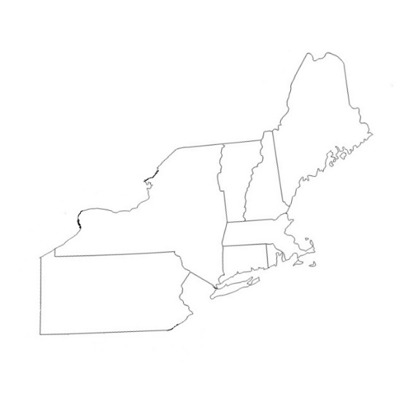

RBGY Whiteout

January 18-20, 2019
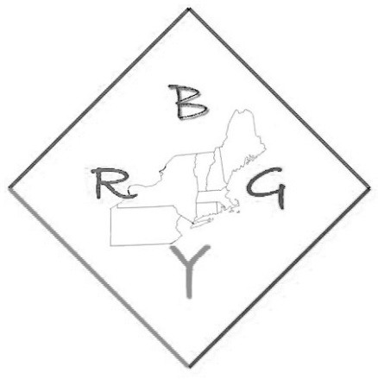
Dear Prospective RBGY Camper and Leaders,
We are very excited another year of RBGY Whiteout! This retreat will be held at Lakeside Christian Camp & Conference Center, in Pittsfield, MA. The dates for this year’s retreat are January 18-20, 2019. RBGY Whiteout will accept Awana clubbers from New England and New York State.
RBGY Whiteout will accept campers in 5th grade through 12th grade. The cost of Whiteout is $139. All registrations should be received by January 1, 2019.
There are no specific Awana requirements for RBGY Whiteout. RBGY Whiteout welcomes campers who have been to RBGY Camp in the summer as well as first time campers. Campers must be at least 9 years old to attend camp.
Send your completed application and camp fee to:
Lori Carlson
15 Lincoln St.
Cromwell, CT 06416
We are excited about RBGY Whiteout and hope to see you there this winter! If you have any questions, please feel free to call or email.

Serving together,
Rick Bennett
RBGY Whiteout Director
(860) 537-0878
camp@rbgycamp.org

January 18-20, 2019

RETREAT LOCATION
Lakeside Christian Camp
195 Cloverdale St.
Pittsfield, MA 01201

WHITEOUT DIRECTOR
Rick Bennett
111 Marvin Road
Colchester, CT 06415
(860) 537-0878

REGISTRARS
Wayne & Lori Carlson
15 Lincoln St.
Cromwell, CT 06416
(860) 632-0245

RBGY Whiteout
January 18-20, 2019

This is a fillable document. Please complete it by typing in all information below,

and then printing the document and returning to the address listed above..

CAMPER INFORMATION

Applicant’s Full Name: ________________________________________________________ Date of Birth: ____ /____ /_____ Age: _______
Preferred name or nickname (if different from above): _________________________ Gender: _______
Address: ______________________________________________ City: _________________ State: _______ Zip: __________
Best Phone: (____) _____-__________ Family E-mail address: ________________________________
Current Grade (please check): __5 __6 __7 __8 __9 __10 __11 __12
Roommate Preference: ________________________________________________________

Medical Information:

Date of last Tetanus Shot: ____ /____ /_____
Person to contact in case of emergency (if parents not available): _______________________________________________________________________________
Relationship: _________________________ Phone # (____) _____-__________

Insurance Information:
This camper is covered by family/medical insurance: ☐ Yes ☐ No
(If no insurance, I agree to pay for any necessary treatments)
Insurance Company: ________________________
Policy Number: ______________________________
Group Number: ______________________________
Name of Policy Holder: ___________________________
Known allergies, medical problems, physical limitations, dietary restrictions, etc:
____________________________________________________________________________________________________________________________________________________________________________________________________________________________________________________________________________________________________________________________________________________________________________________________________________________________________________________________________________________________________________________________________________________________________________________________________

REMEMBER TO REGISTER EARLY

Total camp cost is $139. Send your completed application to:

RBGY WHITEOUT
Lori Carlson
15 Lincoln St
Cromwell, CT 06416

by January 1, 2019. Make check payable to RBGY Camp. The “Parental Consent and Release of Liability” must also be filled out and included with this application.

We recommend that you keep a copy for your records.

RBGY Whiteout
Parental Consent and Release of Liability
Please Print and Provide All Information Requested.

IMPORTANT: THIS DOCUMENT CONTAINS A RELEASE OF LIABILITY. YOU ARE ADVISED TO REVIEW IT CAREFULLY.
Name of Camper: __________________________________________ Camper’s Date of Birth: ____ /____ /_____
Camp Location: Lakeside Christian Camp & Conference Center Dates of Camp: January 18-20, 2019
Consent to Attend Camp
I hereby give permission for Camper to attend and participate in RBGY Whiteout (“Camp”).
Release of Liability
Prior to Camper’s participation in Camp activities, I acknowledge that involvement of Camper in the Camp may involve risk of property damage and of personal injury, illness or even death of Camper, including but not limited to the risks arising from transportation–related activities, recreational activities, accidents in the outdoors and rustic facilities, adverse weather conditions, and injuries and illness as a result of food-borne illnesses and allergic reactions. In addition, I understand that there may be other risks inherent in Camp activities of which I may not be presently aware.
By signing this Parental Consent and Release of Liability, I warrant that Camper is fully capable of safely participating in all Camp activities, and I expressly assume all risks of Camper’s participation, whether such risks are known or unknown to me at this time. I further generally release the New England RBGY Scholarship Camp Association, Inc and its directors, officers, volunteers, and other campers at the Camp, from any and all claims that I or Camper may have against any of them as a result of property damage or personal injury, illness or death of Camper as a result of participation in Camp activities, whether on or off Camp grounds. I agree that this release includes the ordinary, special and inherent risks described above, and other risks that I may not foresee or be aware of at this time. This Release of Liability is given on behalf of myself, Camper, and the heirs, family, estate, administrators, executors, personal representatives and assigns of me and Camper.
Consent to Medical Treatment
If Camper experiences an injury or illness, or has other medical needs, I authorize the Camp’s employees, volunteers, and agents to make such arrangements for Camper’s health and safety, including but not limited to first aid, emergency medical care, ambulance or other transportation to a hospital, medical office, or clinic, testing and examination, and hospital care, and other medical care and treatment (including dental care) as they feel are appropriate in the circumstances. I further agree that I am fully responsible to pay all charges and expenses relating to such care, transportation and treatment and I hereby fully release the New England RBGY Scholarship Camp Association, Inc and its directors, officers, volunteers, from any claims, including claims for medical charges, prescription costs and other expense, I might have as a result of such care, transportation and treatment. My signature below also serves to indicate my willingness for my Health Insurance Company (please provide details in the Medical Information section) to be billed for any and all medical fees and services should they be needed. I agree that I will pay all charges and expenses not covered by insurance.
Additionally, I give permission to the camp nurse to administer non-prescription (over-the-counter) medications as deemed necessary.

(Continued on next page)
RBGY Whiteout
Parental Consent and Release of Liability
Please Print and Provide All Information Requested.
(continued)

Other Releases and Acknowledgements
I understand that, while Camper is participating in Camp activities, photographs, film, audio recordings and videotape of Camper may be taken for use in brochures, videos, releases to the press, and various New England RBGY Scholarship Camp publications and other work product. I do hereby irrevocably grant the New England RBGY Scholarship Camp Association, Inc permission to record, display and/or reproduce my child’s name (first name only), likeness and voice on audio and/or video tape, film or other media, to edit and otherwise modify such media at its discretion, to incorporate the media into any work product, including posting photos and videos to the camp websites, and to use or authorize the use of such media or any portion thereof in any manner or media or by any means, methods or technologies now known or hereafter to be known.
I understand that volunteers from RBGY Camp may provide transportation to or from RBGY Whiteout and I hereby agree that any transportation provided is covered by the release of liability above. Otherwise I will make arrangements for my camper to be brought to and from RBGY Whiteout.
I will ensure Camper only brings clothing that adheres to the Camp Dress Code or similar policy included as part of this package or to be sent in the acceptance package. If Camper fails to abide by established rules and standards of conduct, the New England RBGY Scholarship Camp staff reserve the right to send Camper home. If it becomes necessary to send Camper home, I hereby agree to provide transportation or to make travel arrangements for Camper and to assume the cost of these expenses.
To the extent any provision of this document is found to be unenforceable, such provision shall be deemed severable and shall not affect the enforceability of any other portion of this document, and shall be reformed to be in compliance with the law and construed to most nearly reflect the intent of the parties.
I represent and warrant that I am a parent or legal guardian of the Camper named above and have the full power and authority to enter into this Parental Consent and Release of Liability on behalf of the Camper. By signing below, I acknowledge that this document has been read and understood by me, and also represent that all information provided is accurate. Each legally responsible parent/guardian is required to sign below.

_________________________________________
Parent or Guardian signature

_________________________________________
Name Printed

_____ /_____ /_______
Date Signed

(____) _____-__________
Best phone number at which to reach you

RBGY Whiteout Information Sheet

Where: Lakeside Christian Camp & Conference Center
195 Cloverdale St
Pittsfield, MA 01201
(413) 447-8930 (Emergency only)

Dates: January 18-20, 2019

Registration Time: Registration is from 6pm – 8pm on Friday evening, January 18.

Departure Time: RBGY Whiteout ends at 1:15pm (after lunch) on Sunday, January 20. Please be sure to make arrangements for your child to be picked up at this time.

What To Bring: 1. Appropriate clothing for 3 days of Whiteout, including winter jacket, snow
pants, warm socks, hat, gloves, and boots. You may bring ice skates if you wish.
- Bible, notebook, pen, pencil
- Sleeping bag or sheets, blankets and pillow
- Appropriate footwear for activities (including sneakers for indoor activities)
- Bathroom articles: soap, shampoo, etc, and towels
- Spending money for snackshop
- Any required medicine
- DO NOT bring cell phones, music players, electronic games, etc.

Optional Free-time Skating & broom hockey (frozen lake permitting), winter ga-ga, winter wiffleball,
Activities lots of indoor games and activities, crafts.

Camp Pictures: Camp photos will be uploaded daily to the camp website www.rbgycamp.org.

